Senior Information

In a few weeks, you will walk across the stage at your Commencement ceremony, and just like that, the next phase of your life begins. On behalf of everyone at YES Prep, we are incredibly proud of everything you've done to get to this point, and we wish you the best in all of your future endeavors. Welcome to the alumni family!

Date: Saturday, June 4th, 2022

Time: 9:00 a.m.

Location: Bayou City Event Center (9401 Knight Road, Houston, TX 77045)

Schedule for Seniors

Students must be at the location by 7:15 a.m. (1 hour and 45 minutes before start of the ceremony)

Time | Activity
7:15 a.m. | Seniors are dropped off at Bayou City Event Center
7:45 a.m. | Rehearsal
8:15 a.m. | Pre-Commencement Remarks
8:50 a.m. | Line-up for Processional
8:55 a.m. | Transition to Lobby
9:00 a.m. | Commencement Exercises
10:15 a.m. | Pictures outside with families
10:30 a.m. | Depart Bayou City Event Center to allow the next ceremony to arrive
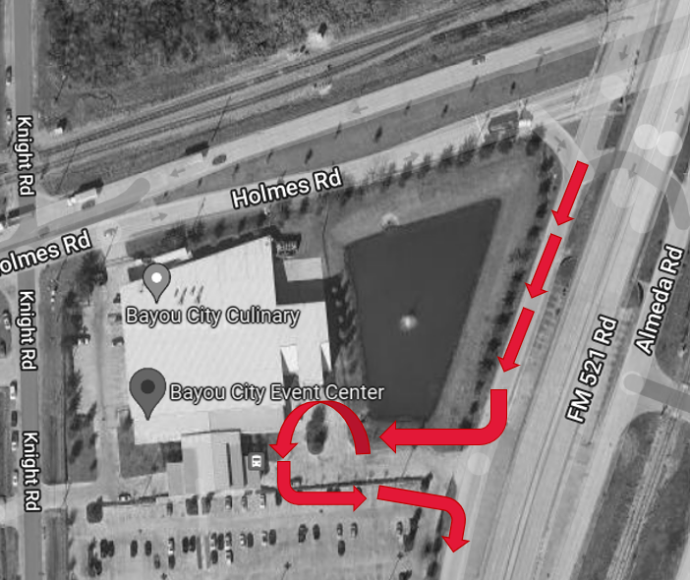
Senior Arrival

Seniors should arrive 1 hour and 45 minutes before the start time of their ceremony.

Your family will drop you off through the Almeda Street Gate to the Bayou City Event Center when arriving. This gate is the first gate, immediately after the light at Almeda and Holmes going south from the South Loop (610).

Seniors should arrive fully dressed in Cap, Gown, and Tassel. When you arrive, remain quiet as another YES Prep School's Commencement may still be in progress. Parents will not be allowed to park or enter the building as the prior ceremony will be in progress.

The drop off lane is marked on the map in Red

Family and Guest Information

Families and guests, you may begin arriving at the Bayou City Event Center and parking one hour before the start of the ceremony at 8:00 a.m. to allow time for parking. Guests can enter the venue 30 minutes prior to the ceremony at 8:30 a.m. when doors open. Parents and guests with mobility devices (like a wheelchair) will be allowed early access to the building 10-15 minutes before doors open.

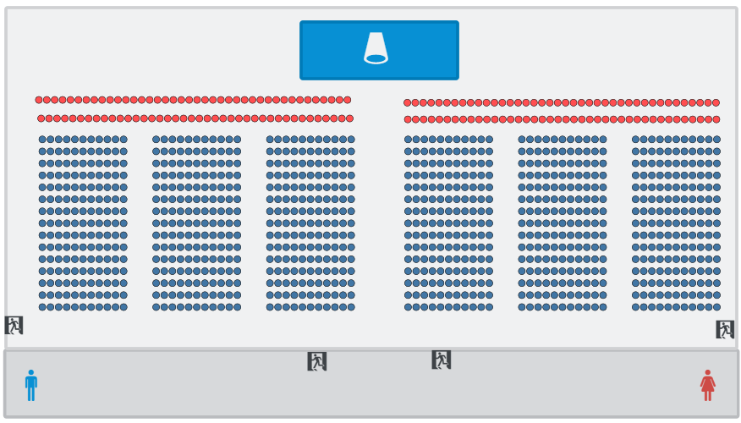
Guest Tickets:

- Each senior will receive 6 tickets for the event for their family and guests in addition to their 1 Yellow Rose Recepient
- Seating at the event will be open, with no assigned seats. Families and guests will be encouraged to arrive together as people will not be able to save seats.
- Families will be able to sit anywhere in the house, seating shown on the seating chart in blue.
- Lap children and babies in strollers do not count towards a graduate's guest count. Lap children and babies will not require a ticket if a family cannot get childcare during a ceremony.
- The event will be live-streamed for graduates' extended family and friends beyond the ticketed guests.

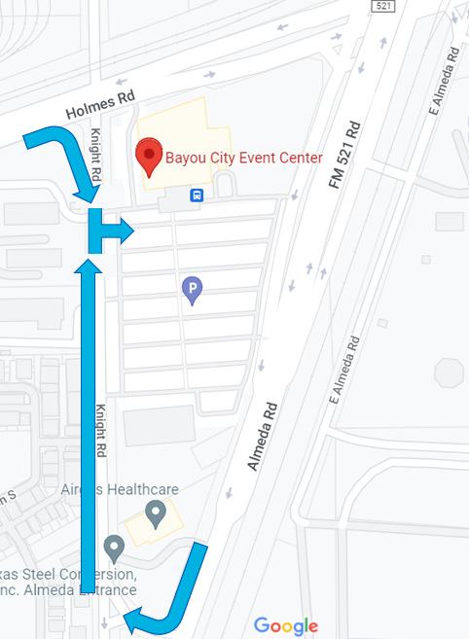
Family and Guest Arrival:

Upon arrival at the Bayou City Event Center, families and guests should arrive through Gate #1 on Knight Road.

Gate #1 on Knight Road is the Address for the Bayou City Event Center in most navigation applications (Google Maps and Waze). Guests access the gate on Knight Road either by turning from Holmes Road or turning right from Almeda.

Guests will be asked to provide their tickets at the door to enter the building.

All guests should arrive at least 10 minutes before the ceremony by 8:50 a.m.

Guests who arrive after this time may be asked to wait briefly outside to not interfere with the processional. Once the processional begins, ushers will hold guests in the lobby until after the National Anthem.

Family & Guest Schedule
8:00 a.m. | Parking opens for parents, families, and guests of the graduating Class of 2022
8:15 a.m. | Doors open for pre-seating for guests utilizing mobility devices or other disabilities
8:30 a.m. | Doors open for parents, families, and guests of the graduating Class of 2022
8:50 a.m. | Guests should be seated
9:00 a.m. | Commencement Ceremony
10:15 a.m. | Ceremony Concludes, parents and guests will exit through the side exits and meet graduates under the portico outside the building
10:15 a.m. | Pictures outside with families
10:30 a.m. | Depart Bayou City Event Center to allow the next ceremony to arrive

Venue Rules:

- No noisemakers, bull horns, glitter, confetti, streamers, or helium balloons are allowed inside the building. Balloons and other items should be given to the graduate at home or remain in the car. Flowers are permitted, but we discourage any glass vases for safety reasons.
- There is no charge for parking in the Bayou City Event Center parking lot.
- The seating is open, and families will not be able to hold once inside the venue. Please ensure your party arrives together to be seated together. Ushers will ensure families are not saving seats.
- Although not required, masks are encouraged inside the venue. People will be traveling from around Texas and even abroad to attend the event.

Senior Attire:

Please arrive at Bayou City Event Center appropriately dressed in your event clothes with your Cap, Gown, and Tassel. The expected dress code for Commencement for Seniors is Business Professional Attire. Below are some examples of what is Business Professional Dress:

Examples of Professional Dress | What is Not Professional Dress
- Button-Down Shirt and Tie or Blouse  - Slacks  - Long Skirt  - Dress  - Dress Shoes, Boots, Heels (Cone, Wedge, Block, or Flare), or Flats | - Jeans  - T-Shirts or Polos  - Tennis Shoes  - Work Boots  - Heels greater than 3 inches (you will be going up and down steps or uneven surfaces).

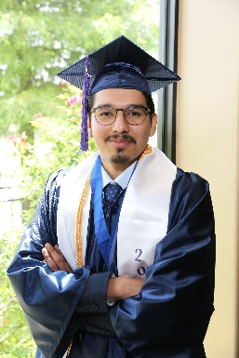 | 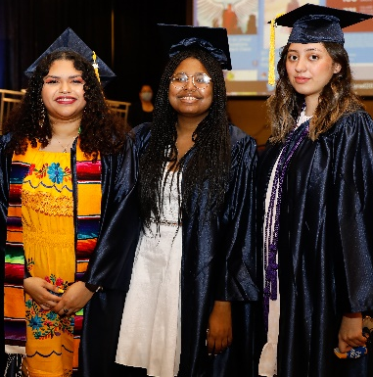 |  |  | 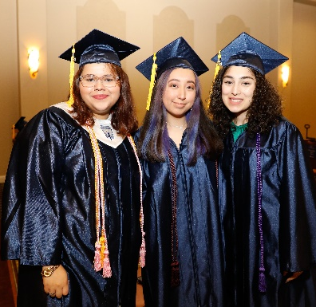

Reminders

- Robes and tassels: If you have not done so already, please place your order for your robes and Class of 2022 tassels from Herff Jones. Graduates should wear Robes at all times during the ceremony. Robes should be zipped up / closed during the ceremony. Do not wear your robe open.

- Tassels: Wear your Class of 2022 tassel on the right side of your head before the ceremony. We will instruct you to move it from right to left during the ceremony at the appropriate time.

- Request time off work: Commencement is scheduled to occur on Saturday, June 4th. Please request the full day of work and encourage your family members to do the same if you currently work.

- Be On Time! It is imperative that you arrive on time to the ceremony as noted – 1 hour 45 minutes before the start of your Commencement Ceremony. There is only a short window in between all YES Commencement Ceremonies. We need to ensure we have everyone in their correct order and ready to go. Given the difficulties inherent in gathering staff and students after the ceremony, we will take pictures before the start of Commencement. Therefore, all students must be present and dressed upon arrival. When you arrive in the lobby area, we can all help each other with robes, caps, tassels, etc.

- Photos: Photos of each graduate will be taken as they walk across the stage by a professional photographer. Please communicate this to your family. Families are asked not to get out of their chairs to take photos during the ceremony, which can be disruptive to the program. All photos taken will be free and available to our students and families on the YES Prep Website.

